**Core Html Assignment**

Question1.

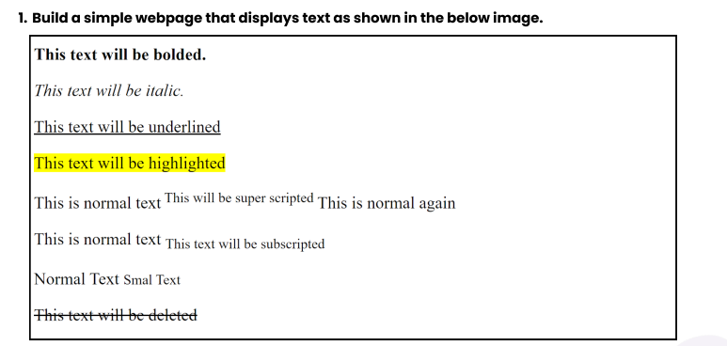

Answer.

<!DOCTYPE html>

<html lang="en">

<head>

    <meta charset="UTF-8">

    <meta name="viewport" content="width=device-width, initial-scale=1.0">

    <title>Text Styling Example</title>

    <style>

        body {

            font-family: Arial, sans-serif;

            line-height: 1.6;

        }

        .highlight {

            background-color: yellow;

        }

        .small-text {

            font-size: smaller;

        }

    </style>

</head>

<body>

    <p><strong>This text will be bolded.</strong></p>

    <p><em>This text will be italic.</em></p>

    <p><u>This text will be underlined</u></p>

    <p><span class="highlight">This text will be highlighted</span></p>

    <p>This is normal text <sup>This will be super scripted</sup> This is normal again</p>

    <p>This is normal text <sub>This text will be subscripted</sub></p>

    <p class="small-text">Normal Text Smal Text</p>

    <p><del>This text will be deleted</del></p>

</body>

</html>

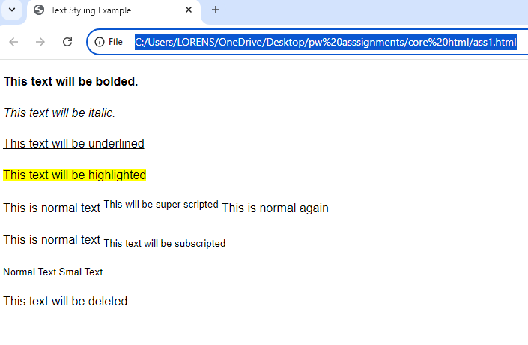

Question2.

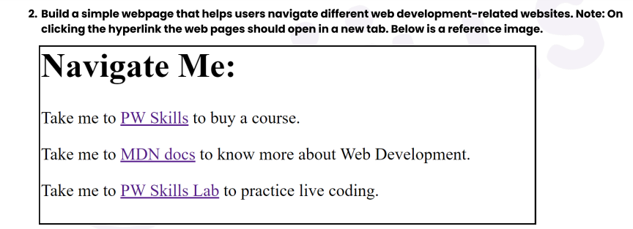

<!DOCTYPE html>

<html lang="en">

<head>

    <meta charset="UTF-8">

    <meta name="viewport" content="width=device-width, initial-scale=1.0">

    <title>Navigate Me</title>

</head>

<body>

<h1>Navigate Me:</h1>

<p>

    Take me to <a href="https://pwskills.com" target="_blank">PW Skills</a> to buy a course.

</p>

<p>

    Take me to <a href="https://developer.mozilla.org" target="_blank">MDN docs</a> to know more about Web Development.

</p>

<p>

    Take me to <a href="https://lab.pwskills.com" target="_blank">PW Skills Lab</a> to practice live coding.

</p>

</body>

</html>

Output:

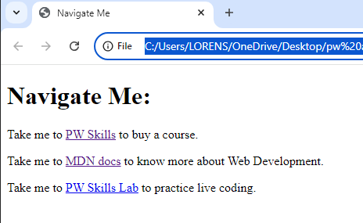

Question3:

Build a simple blog web page with 3 pages home, web development, and web design. Each page must contain hyperlinks to other pages in the top, a heading of the page topic and a paragraph of information. For the home page you can add some information about yourself.

Ans:

index.html

<!DOCTYPE html>

<html lang="en">

<head>

    <meta charset="UTF-8">

    <meta name="viewport" content="width=device-width, initial-scale=1.0">

    <title>Home - My Blog</title>

</head>

<body>

    <nav>

        <a href="index.html">Home</a> |

        <a href="web-development.html">Web Development</a> |

        <a href="web-design.html">Web Design</a>

    </nav>

    <h1>Welcome to My Blog</h1>

    <p>Hi, I'm lorens mishra , a passionate web developer and designer. This is my blog where I share insights and tutorials about web development and design.!</p>

</body>

</html>

**web-development.html**

<!DOCTYPE html>

<html lang="en">

<head>

    <meta charset="UTF-8">

    <meta name="viewport" content="width=device-width, initial-scale=1.0">

    <title>Web Design - My Blog</title>

</head>

<body>

    <nav>

        <a href="index.html">Home</a> |

        <a href="web-development.html">Web Development</a> |

        <a href="web-design.html">Web Design</a>

    </nav>

    <h1>Web Design</h1>

    <p>Web design refers to the design of websites that are displayed on the internet. It usually refers to the user experience aspects of website development rather than software development.</p>

</body>

</html>

**Web-design.html**

<!DOCTYPE html>

<html lang="en">

<head>

    <meta charset="UTF-8">

    <meta name="viewport" content="width=device-width, initial-scale=1.0">

    <title>Web Development - My Blog</title>

</head>

<body>

    <nav>

        <a href="index.html">Home</a> |

        <a href="web-development.html">Web Development</a> |

        <a href="web-design.html">Web Design</a>

    </nav>

    <h1>Web Development</h1>

    <p>Web development is the work involved in developing a website for the Internet or an intranet. It ranges from creating simple static pages to complex web applications, e-commerce platforms, and social networks.</p>

</body>

</html>

**Output1:**

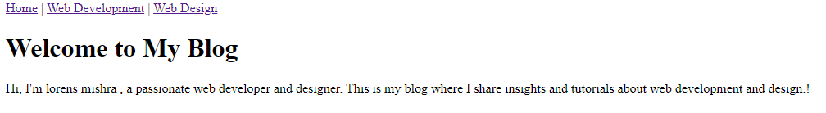

**Output2:**

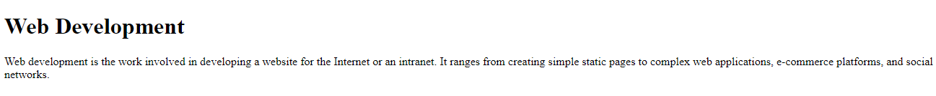

**Output3:**



Question 4:

Create an ordered list of HTML tags. Each list item must include the tag name and some information about the tag.

Answer:

<!DOCTYPE html>

<html lang="en">

<head>

    <meta charset="UTF-8">

    <meta name="viewport" content="width=device-width, initial-scale=1.0">

    <title>Ordered List of HTML Tags</title>

</head>

<body>

    <h1>HTML Tags</h1>

    <ol>

        <li><strong>&lt;p&gt;</strong> - The paragraph tag defines a block of text.</li>

        <li><strong>&lt;a&gt;</strong> - The anchor tag creates a hyperlink.</li>

        <li><strong>&lt;img&gt;</strong> - The image tag embeds an image in the document.</li>

        <li><strong>&lt;div&gt;</strong> - The division tag defines a section or division in an HTML document.</li>

        <li><strong>&lt;h1&gt; to &lt;h6&gt;</strong> - These tags define HTML headings, from the most important (h1) to the least important (h6).</li>

    </ol>

</body>

</html>

Output:

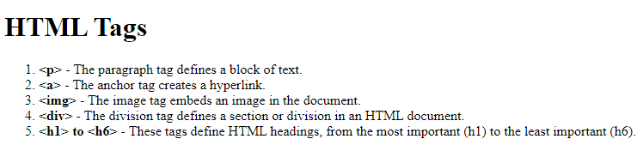

Question5:

Create a descriptive list of full stack web development tech stack using <dl> tag. Each term should be a tech stack name and each description should be a brief explanation of what the tech stack is used for.

<!DOCTYPE html>

<html lang="en">

<head>

    <meta charset="UTF-8">

    <meta name="viewport" content="width=device-width, initial-scale=1.0">

    <title>Full Stack Web Development Tech Stack</title>

</head>

<body>

    <h1>Full Stack Web Development Tech Stack</h1>

    <dl>

        <dt>HTML</dt>

        <dd>HTML (HyperText Markup Language) is the standard language for creating web pages.</dd>

        <dt>CSS</dt>

        <dd>CSS (Cascading Style Sheets) is used for styling and designing web pages.</dd>

        <dt>JavaScript</dt>

        <dd>JavaScript is a programming language used to create dynamic and interactive web content.</dd>

        <dt>Node.js</dt>

        <dd>Node.js is a JavaScript runtime built on Chrome's V8 JavaScript engine, used for server-side development.</dd>

        <dt>React</dt>

        <dd>React is a JavaScript library for building user interfaces, maintained by Facebook.</dd>

        <dt>MongoDB</dt>

        <dd>MongoDB is a NoSQL database used for storing data in JSON-like format.</dd>

    </dl>

</body>

</html>

Output:

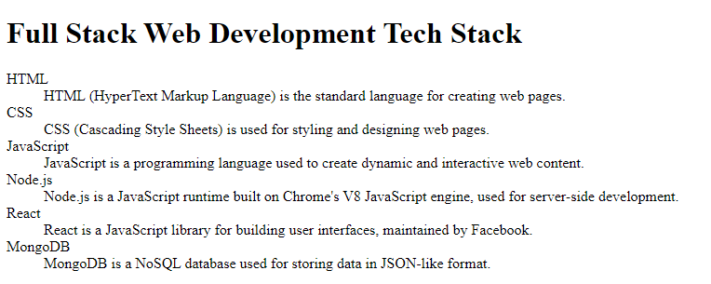

Question6:

Create an ordered list of the full stack web development tech stack HTML, CSS, JS. For each tech stack, create a table that lists the tech stack name, its primary cases and some key features or benefits. Below is a reference image.

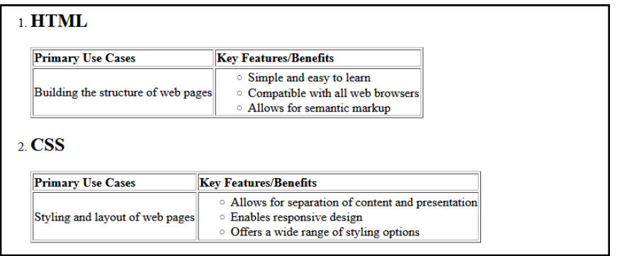

Answer:

<!DOCTYPE html>

<html lang="en">

<head>

    <meta charset="UTF-8">

    <meta name="viewport" content="width=device-width, initial-scale=1.0">

    <title>Full Stack Web Development Tech Stack</title>

    <style>

        table {

            width: 100%;

            border-collapse: collapse;

            margin-bottom: 20px;

        }

        table, th, td {

            border: 1px solid black;

        }

        th, td {

            padding: 10px;

            text-align: left;

        }

        th {

            background-color: #f2f2f2;

        }

    </style>

</head>

<body>

    <h1>Full Stack Web Development Tech Stack</h1>

    <ol>

        <li>HTML</li>

        <table>

            <thead>

                <tr>

                    <th>Tech Stack</th>

                    <th>Primary Use Cases</th>

                    <th>Key Features/Benefits</th>

                </tr>

            </thead>

            <tbody>

                <tr>

                    <td>HTML</td>

                    <td>Structuring web pages, defining the content of web pages.</td>

                    <td>

                        - Easy to learn and use.<br>

                        - Widely supported by all browsers.

                    </td>

                </tr>

            </tbody>

        </table>

        <li>CSS</li>

        <table>

            <thead>

                <tr>

                    <th>Tech Stack</th>

                    <th>Primary Use Cases</th>

                    <th>Key Features/Benefits</th>

                </tr>

            </thead>

            <tbody>

                <tr>

                    <td>CSS</td>

                    <td>Styling and designing web pages, layout control.</td>

                    <td>

                        - Enables responsive design.<br>

                        - Supports animations and transitions.

                    </td>

                </tr>

            </tbody>

        </table>

        <li>JavaScript</li>

        <table>

            <thead>

                <tr>

                    <th>Tech Stack</th>

                    <th>Primary Use Cases</th>

                    <th>Key Features/Benefits</th>

                </tr>

            </thead>

            <tbody>

                <tr>

                    <td>JavaScript</td>

                    <td>Creating dynamic and interactive web content, client-side scripting.</td>

                    <td>

                        - High interactivity and user engagement.<br>

                         - Cross-platform and browser compatibility.

                    </td>

                </tr>

            </tbody>

        </table>

    </ol>

</body>

</html>

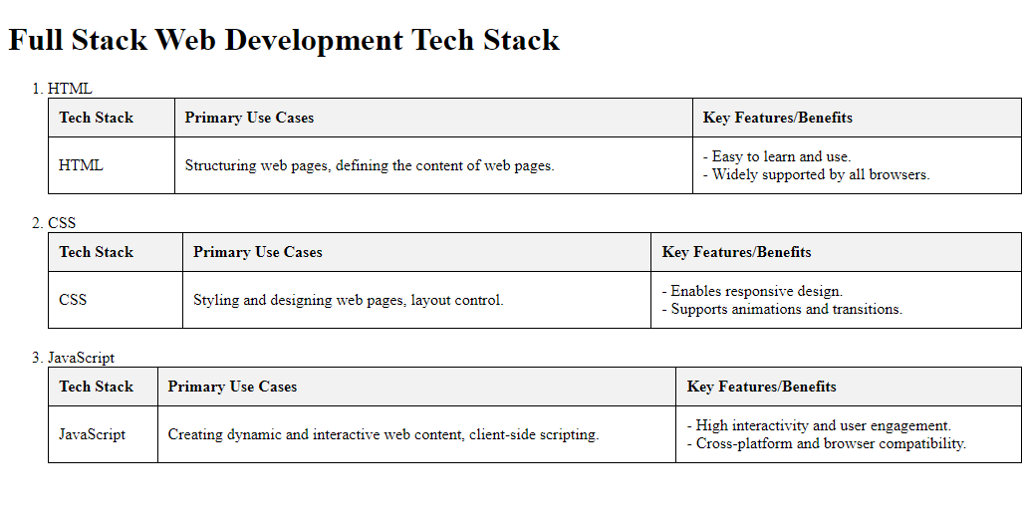

Question7:

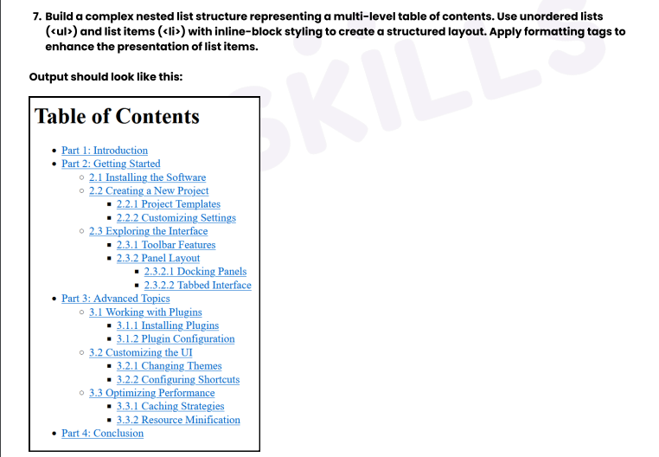

Answer:

<!DOCTYPE html>

<html lang="en">

<head>

    <meta charset="UTF-8">

    <meta name="viewport" content="width=device-width, initial-scale=1.0">

    <title>Table of Contents</title>

</head>

<body>

<h1>Table of Contents</h1>

<ul>

    <li><a href="#part1">Part 1: Introduction</a></li>

    <li><a href="#part2">Part 2: Getting Started</a>

        <ul>

            <li><a href="#installing">2.1 Installing the Software</a></li>

            <li><a href="#creating">2.2 Creating a New Project</a>

                <ul>

                    <li><a href="#templates">2.2.1 Project Templates</a></li>

                    <li><a href="#settings">2.2.2 Customizing Settings</a></li>

                </ul>

            </li>

            <li><a href="#exploring">2.3 Exploring the Interface</a>

                <ul>

                    <li><a href="#toolbar">2.3.1 Toolbar Features</a></li>

                    <li><a href="#panel">2.3.2 Panel Layout</a>

                        <ul>

                            <li><a href="#docking">2.3.2.1 Docking Panels</a></li>

                            <li><a href="#tabbed">2.3.2.2 Tabbed Interface</a></li>

                        </ul>

                    </li>

                </ul>

            </li>

        </ul>

    </li>

    <li><a href="#part3">Part 3: Advanced Topics</a>

        <ul>

            <li><a href="#plugins">3.1 Working with Plugins</a>

                <ul>

                    <li><a href="#installing-plugins">3.1.1 Installing Plugins</a></li>

                    <li><a href="#configuring-plugins">3.1.2 Plugin Configuration</a></li>

                </ul>

            </li>

            <li><a href="#customizing">3.2 Customizing the UI</a>

                <ul>

                    <li><a href="#changing-themes">3.2.1 Changing Themes</a></li>

                    <li><a href="#configuring-shortcuts">3.2.2 Configuring Shortcuts</a></li>

                </ul>

            </li>

            <li><a href="#optimizing">3.3 Optimizing Performance</a>

                <ul>

                    <li><a href="#caching">3.3.1 Caching Strategies</a></li>

                    <li><a href="#minification">3.3.2 Resource Minification</a></li>

                </ul>

            </li>

        </ul>

    </li>

    <li><a href="#part4">Part 4: Conclusion</a></li>

</ul>

</body>

</html>

Output:

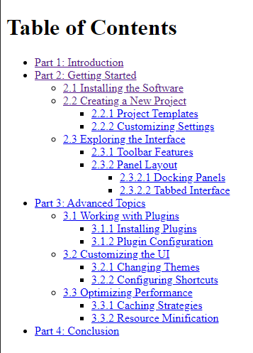

Question8:

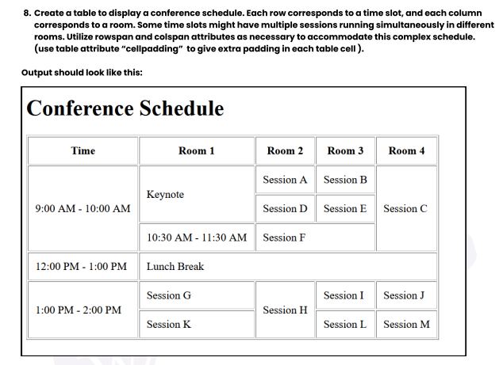

Answer:

<!DOCTYPE html>

<html lang="en">

<head>

    <meta charset="UTF-8">

    <meta name="viewport" content="width=device-width, initial-scale=1.0">

    <title>Conference Schedule</title>

</head>

<body>

<h1>Conference Schedule</h1>

<table border="1" cellpadding="10">

    <tr>

        <th>Time</th>

        <th>Room 1</th>

        <th>Room 2</th>

        <th>Room 3</th>

        <th>Room 4</th>

    </tr>

    <tr>

        <td rowspan="3">9:00 AM - 10:00 AM</td>

        <td rowspan="2">Keynote</td>

        <td>Session A</td>

        <td>Session B</td>

        <td rowspan="3">Session C</td>

    </tr>

    <tr>

        <td>Session D</td>

        <td>Session E</td>

    </tr>

    <tr>

        <td>10:30 AM - 11:30 AM</td>

        <td colspan="2">Session F</td>

    </tr>

    <tr>

        <td>12:00 PM - 1:00 PM</td>

        <td colspan="4" align="center">Lunch Break</td>

    </tr>

    <tr>

        <td rowspan="2">1:00 PM - 2:00 PM</td>

        <td>Session G</td>

        <td rowspan="2">Session H</td>

        <td>Session I</td>

        <td>Session J</td>

    </tr>

    <tr>

        <td>Session K</td>

        <td>Session L</td>

        <td>Session M</td>

    </tr>

</table>

</body>

</html>

Output:

